**MEDICAL EXPERT SYSTEM**

**A CASE STUDY OF BUSIA DISTRICT HOSPITAL**

**Project Report submitted to Faculty of Science in partial fulfilment for the award of Bachelor of Science in Information Technology at University of Science & Technology**

April, 2013

# DECLARATION

I ………………..do hereby declare that this Project Report is my own work and has not been copied from any material or published for any other degree award to any other University before.

Signed: …………………… Date: ……………..

# 

# Approval

This is to certify that this project documentation on Expert medical system was done under my supervision and was presented on my approval

Supervisor; Mr.Matoke

Signed: ................................... ...............Date: ...........................................

Department of Computer Science,

# Dedication

Special dedication to my Parents Mrs and Mrs. W. J. Omusebe, Your support and encouragement has been a blessing. You were always there for me and I feel indebted. Thank you for standing by me.

# Acknowledgement

Write here…………..

# Abstract

This project aims at developing an expert system for patients. Patients will be able to enter their symptoms and get to know what they are suffering from and get prescription for drugs. If the patients needs to go for lab tests it will order the lab tests and once the results are out it will give the necessary drug prescription. This will ensure easy access to medical services. It will assist the doctors when offering treatment. This proposal covers the following areas: the introduction, problem definition, problem justification, research elements, systems requirements, project schedule and budget.

# Table of contents

DECLARATION ii

Approval iii

Dedication iv

Acknowledgement v

Abstract vi

Table of contents vii

CHAPTER 1 1

1.0 Introduction 1

1.1 Problem Definition 1

CHAPTER 2 3

2.0 LITERATURE REVIEW 3

2.1 IT AND PERFORMANCE 3

2.2 IT CHALLENGES 3

2.3 IMPLEMENTATION OF ICT 4

2.4 INFORMATION SYSTEMS 5

CHAPTER 3 6

3.0 METHODOLOGY 6

3.O GENERAL OVERVIEW 6

3.1 Materials and Methodology 6

3.2 materials required 7

3.2.1 Software requirements 7

3.2.2 Hardware requirements 7

3.3 Functional and nonfunctional requirements 8

3.3.1 Functional Requirements 8

3.3.2 Non Functional Requirements 8

3.4 Design 8

3.4.1 General overview 8

3.4.2Context diagram 8

3.4.1 Architectural design 9

3.4.3 Data flow diagrams 10

3.4.4 Database design 13

3.4.5 Screenshots 14

CHAPTER 4 18

4.0 IMPLEMENTATION AND TESTING 18

4.1 CODING 18

4.2 MODULE INTEGRATION AND TESTING 18

4.3 UNIT TESTING 19

4.4 VALIDATION TESTING 19

CHAPTER 5 20

5.0 SUMMARY 20

5.1 Recommendations 20

5.2 Conclusion 20

APPENDIX 21

Project schedule 21

REFERENCES/BIBLIOGRAPHY 41

# CHAPTER 1

## 1.0 Introduction

This project aims at creating a system that acts as a doctor and provides computerized automatic medical diagnosis and prescription of drugs to patients. In clinics and hospitals, this system will assist the doctors and clinical officers when attending to patients. This can be placed at public places and home so that people can have their clinical observations easily, instantly and cheaply. In rural areas where there is lack of doctors, this system can surely serve as a boon. It can also be used by medical students. It can also be used when there is shortage of doctors or when there is a crisis e.g. during the doctors strike. The main aim of coming up with this system is to computerise the medical system. The patients will be served fast and human errors will be avoided

The beneficiaries of this system are the patients, the Doctors, the nurses, the clinical officers and the medical students. The system will reduce errors when diagnosing and giving medication. Time spend in thinking will be reduced. Medical students will be able to learn how to diagnose and give treatment. It will also be helpful where there is doubt in diagnosis or prescription.

## 1.1 Problem Definition

Health has been one of the most significant considerations in the fortification of human  
civilization. However bulk of the population is still out of the spectrum due to the lack of health  
personnel and doctors, at proper place and time. This problem, to some extent can be solved by the use of available technologies thereby giving the poor and the needy something rather than not. It is also useful when the doctors have many patients like in district hospitals. This will ensure that patients don’t have to queue on for long waiting to see the doctor few doctors available.

**1.2 Purpose**To create an expert system medical system for the patients

**1.3 Objectives of the project**

* To develop a system that will diagnose patients diseases and give drug prescriptions
* To provide quick access to medical care for patients

**1.4 Limitations of the system**

* Initial cost of installing the system are high but the benefits outweigh the cost.
* The users of the system will need training
* It may not be easy for people to accept change
* Some problems need doctors attention e.g. surgery

# 

# CHAPTER 2

# 2.0 LITERATURE REVIEW

# 2.1 IT AND PERFORMANCE

IT contributes to organization performance by bringing efficiency in an organization. It Saves time on certain duties like Filing and report writing., it has better stock organization e.g. linked to computer system, it has better staff organization e.g. computerized duty rota’s, staff lists, and Saves money in the long-term as the organization is better organized in general. (Barua A. et al. 1995)

IT increases productivity and speed of work. It improves accuracy as computers tend to make fewer mistakes than humans, it gives quick communication and , saves labour costs as fewer workers may be required. (Revell 1997)

# 2.2 IT CHALLENGES

IT Implementation Challenges are lack of awareness about the benefits, mindset fear, unwillingness to face changes from the highest decision making levels to the lowest operation levels. There is also fear of change, lack of clear perception of how ICT resources can be sustainably managed, the operational risks and likely escalating costs of poor information resource management. During the process of computerization the challenges are financial resources, training of staff, knowledge to make informed investment and ICT strategic plan.

Initial cost of installing the IT equipment is high. The organization will also have to meet the cost of training the staff to use ICT. Some staff may also feel their jobs threatened because new machines do the work. Another challenge is in case of a machine breakdown it can result in work having to be stopped until it is fixed. This may reduce staff motivation. This can happen if the staff feel that ICT has eliminated personal contact ( Barua et al. 1995)

## 2.3 IMPLEMENTATION OF ICT

When designing and implementing an IT system you need to identify the user requirements, then produce a design specification, including specifying information sources, input, process and output requirements, and the types of application software needed ,test the system under a range of conditions, implement the system, produce user documentation for the system, evaluate the design and implementation of the system, by checking against user requirements, and making any necessary modifications and improvements.( Araya S. (2007))

The desire to try and retain staff as long as possible and improve advancement opportunities for existing employees is treated as a high priority in most establishment employment strategies (Robert Taylor, 2001).

When implementing use of ICT old staff should be trained so that they can be retained in the organization.

# 2.4 INFORMATION SYSTEMS

The term Information System (IS) refers to “*a set of interrelated components that collect (or retrieve), process, store and distribute information to support decision making and control in an organization”* (Loudon & Loudon, 1944).

James A. Brien simply defines it as a system that accepts data resources as an input and processes them into information products as output.

The above two definitions seem not to be satisfactory that is why I concur with the definition given by Raph M. Stair and George. They define an information system as “*a set of interrelated components that collect, manipulate, store and disseminate data and information and provide feedback mechanisms to meet an objective*.”

# CHAPTER 3

# 3.0 METHODOLOGY

# 3.O GENERAL OVERVIEW

This chapter covers the identification and formulation of data flow diagrams (model) which constituted architectural design and the identification of data structure for the application which constituted data structure design of this project.

**System front end:**This is the interface that the user interacts with in order to enter data. It is made possible by using web browsers e.g. Mozilla Firefox and internet explorer

**System backend:** The back end of the system consists of the MYSQL database and Apache server. MYSQL is used as a storage media for data entries (made from the webpage module) and processed information. The user is not aware of this as he/she just interacts with the interface provided for them in the front end.

**3.2 DESIGN METHODOLOGY**

Development of the system used the Waterfall model of the systems development life cycle. Each of the phases in the process plan had an equivalent phase in the model which implied a one to one correspondence that helped put in check the development of the system. The stages in the waterfall model describe a stepwise system development methodology that stipulates a guideline to be used in each stage of the system evolution.

## 3.1 Materials and Methodology

Waterfall model is a sequential design process, in which progress is seen as flowing steadily downwards through the phases of; Conception, Initiation, Analysis, Design, Construction, Testing, Production/implementation and Maintenance. Thus in waterfall model, a developer moves on to the next phase after the previous phase has been done.

Brief description of the waterfall model;

1. Definition study/analysis: During this phase research was conducted which involved brainstorming about the software, what was going to be and its purpose too
2. Basic Design: when the first phase got successfully completed, the next step was formulating a basic design for the software.
3. After the validation and approval of the basic design, a more elaborate technical design. Here the functional requirements of each part were mentioned on paper and divided into modules.
4. Construction: the source code was written.
5. Testing: the whole design and its implementation was put to test to check its functionality.
6. Maintenance and management: ensuring that the system acts as desired.

**Advantages of Waterfall model**

* The project required the fulfillment of the uploading phase before having users into the system. Flaws were noticed early
* It’s widely used and common to many developers.

## 3.2 materials required

### 3.2.1 Software requirements

* Windows or linux based operating system
* Mysql database version 5.1.36 or above.
* Apache server application.
* PHPdev 5.0.3 or above.
* Macromedia Dreamweaver cs5.5.
* Web browser preferably mozilla or Google Crome.
* Java programming language

### 3.2.2 Hardware requirements

* Pentium IV 2.0 GHz or compatible.
* 512 MB RAM (Minimum)
* 10GB Hard disk for storage.

This part contains two types of requirements:

* Functional requirements – these are statements of services the system should provide or is expected to provide.
* Non-functional requirements- These are constraints on the services or functions offered by the system.

## 3.3 Functional and nonfunctional requirements

### 3.3.1 Functional Requirements

* Keep database for symptoms
* Keep database of diseases
* Keep database for medicines
* Users can select their symptoms
* The system can diagnose what patient is suffering from
* Users can get drug prescription

### 3.3.2 Non Functional Requirements

* The system is supposed to give appointments to patients with special cases

# 3.4 Design

## 3.4.1 General overview

System design is an integral of software designs. In this section we shall look into the data aspect and component interface for Medical expert system

## 3.4.2Context diagram

The following is a representation of the context diagram of the Medical Expert system data flow diagram. The diagram illustrates all the information that is received and sent by the System.

**The context diagram**

## 3.4.1 Architectural design

In this design level, the basic structure framework identifies the major components of a system and the communication between these components.

**Architectural design diagram**

## 3.4.3 Data flow diagrams

**Login flow chart**

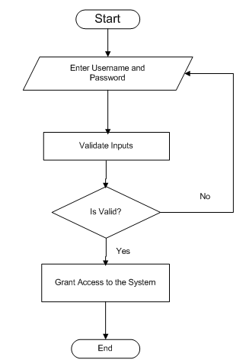

Set criteria for the password

Home page

**Registration flow chart**

Invalid inputs

Input new person

Records Updated in the Database

Verification

Yes

No

**User interaction with the system flow chart**

Fill in the registration form.

Submit the form

Choose symptoms from the list

Store data to database

Login

Check diagnosis and go for lab test to confirm

Enter lab results in the system

Get drug prescription from the system

## 3.4.4 Database design

The data structure used in the system represented by this report is a Mysql database. It is made up of four tables.

**Diagnosis table**

Diagnosis_ID (pk)

Disease *char* (15)

Drug *char* (15)

**Diseases table**

Disease_ID (pk)

Symptoms c*har* (15)

Disease *char* (15)

**Users table**

User_ID (pk) *int(10)*

Name - *varchar (15)*

Date -*date* (10)

Address –*varchar*(50)

Email -

Password

**General_aches table**

ID (pk)

Aches *char* (15)

Medicine *char* (15)

**Lab table**

Lab_ID(Pk)

Results positive *char* (15)

Results negative *char* (15)

## 3.4.5 Screenshots

Several screenshots have been used to describe the design of the system

Login screen

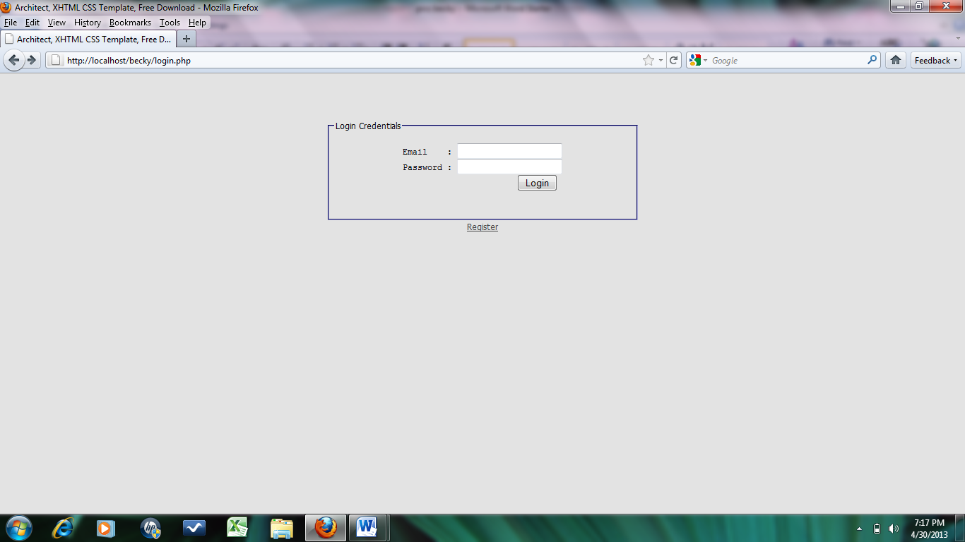

Registration screen



Homepage screen

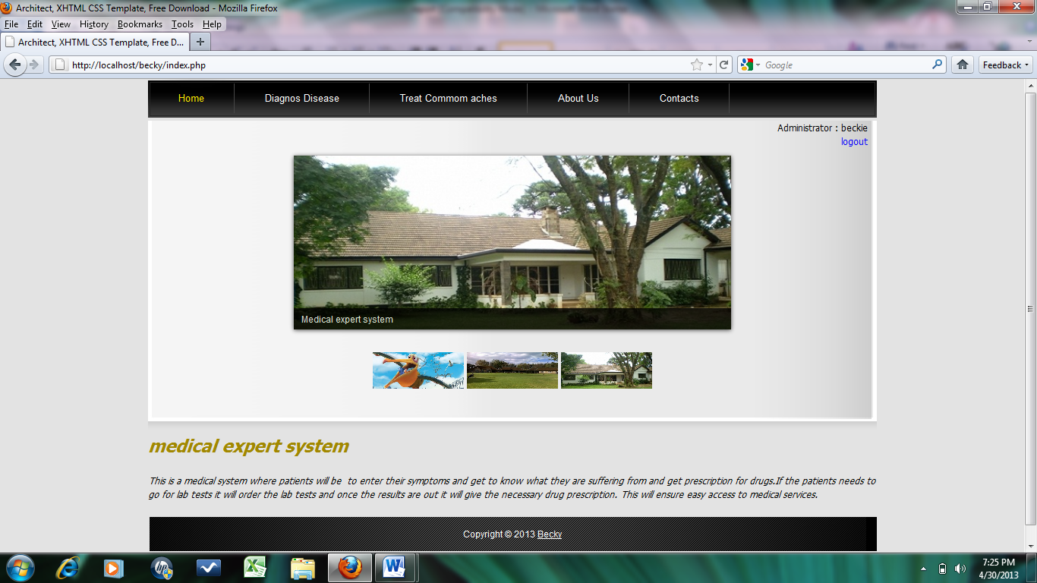

Symptoms screen

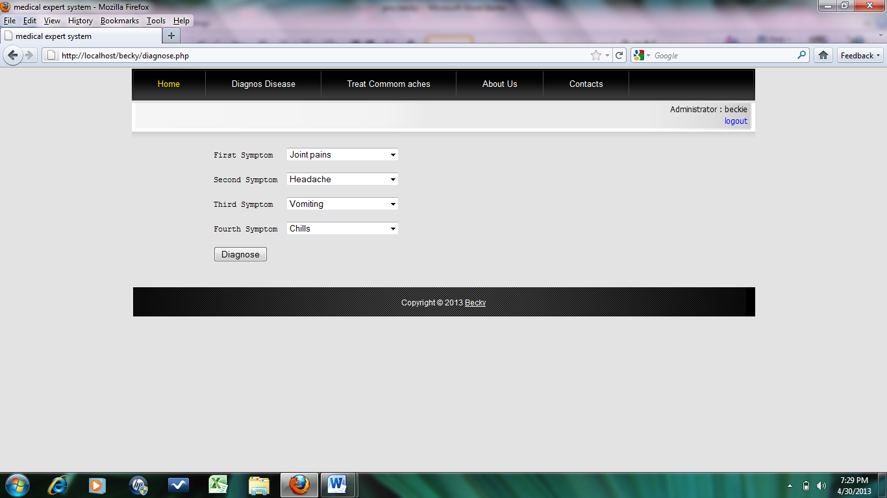

Diagnosis screen

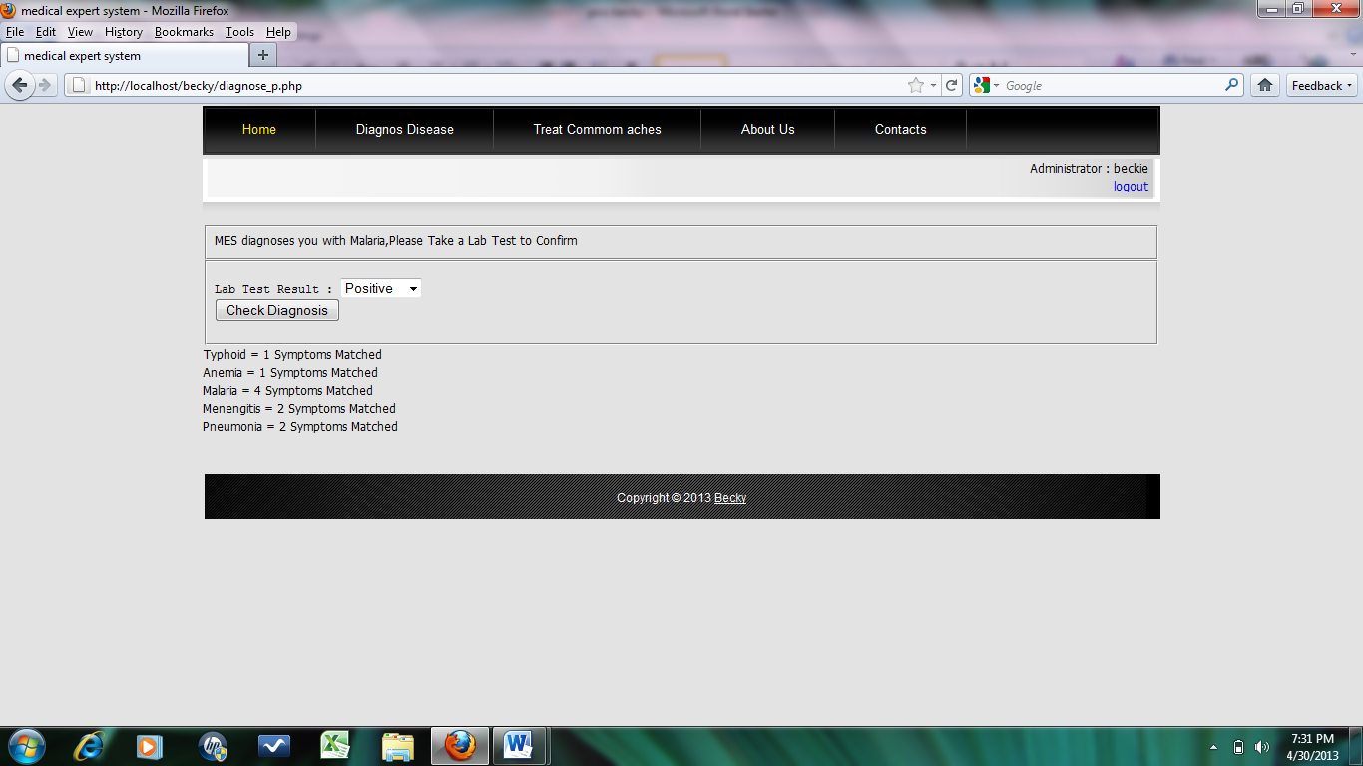

Medication screen

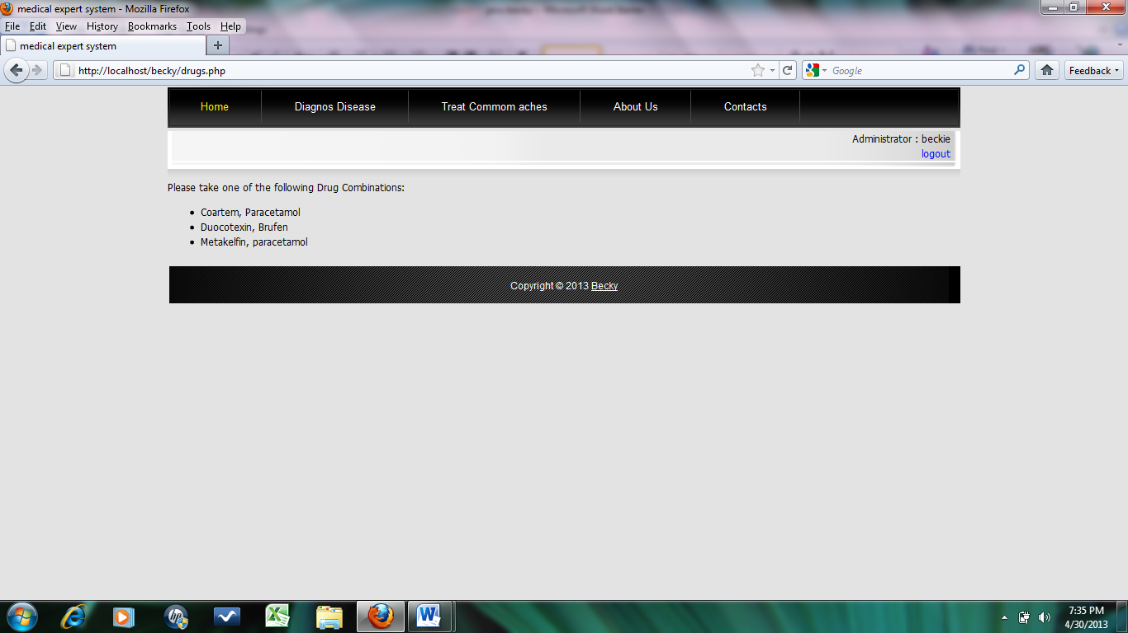

Common aches screen

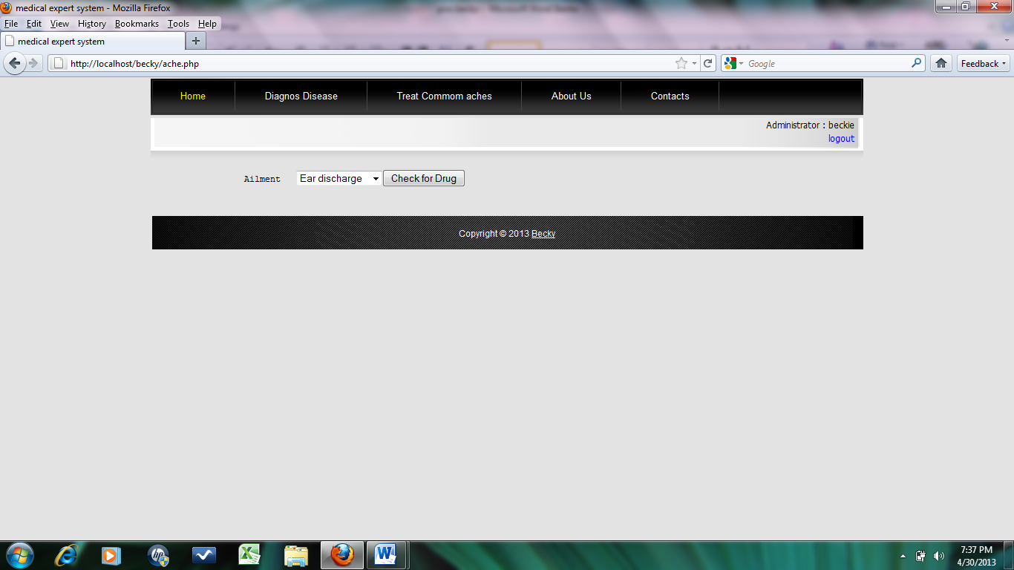

Medication for common aches screen

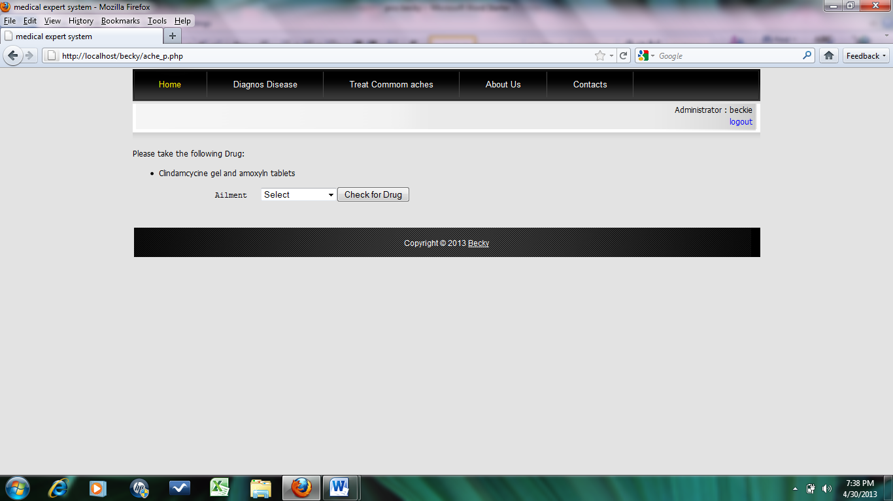

# CHAPTER 4

# 4.0 IMPLEMENTATION AND TESTING

# 4.1 CODING

Coding was done using the following programming languages

* PHP programming language
* HTML
* Java script

To ease the process of coding, the project was broken down into small modules so that each module can be developed, tested and integrated individually. Modularity enhances design clarity which in turn makes implementation easy as well as debugging, testing, documenting and maintenance of the software.

# 4.2 MODULE INTEGRATION AND TESTING

Integration testing is a systematic technique for developing a system while at the same time conducting tests to uncover errors associated with interfacing. The main aim is to take unit tested modules and build a program structure that has been dictated by design.

Having written the codes for each module, the modules were integrated (combined) and then the resultant main module was tested for conformity and completeness.

# 4.3 UNIT TESTING

Unit testing focuses on checking for validity of the smallest unit of software component or module. Using the component-level design description as a guide, important control paths were tested to uncover errors within the boundary of the module.

The resultant system after the integration of the modules was tested to ascertain its correctness in terms input, processing and output. This was done by executing prepared test scenarios.

# 4.4 VALIDATION TESTING

The system was tested using prepared test cases to ascertain that the right system was built. It was also done to test if the system satisfied all the problem requirements of the project. The system was also given out to fellow students to work with and identify any faults in its functionalities.

# 

## 

# CHAPTER 5

# 5.0 SUMMARY

During this project I applied the software development lifecycle from requirement engineering to documentation. I have also been able to apply web programming skills to design the project using html and PHP languages. Lastly, the project has also enabled me to interact and use the various CASE tools Mysql Database server, and Adobe Dreamweaver CS5 which is one tool that has enabled me in designing interfaces.

# 5.1 Recommendations

I would highly recommend that Busia District hospital and other hospitals in Kenya should adopt the new Medical expert system. Apparently a doctor’s basic salary is about Kshs.900,000 per year. If the hospital was to reduce the number of doctor from ten to five the organization will save approximately Kshs. 4,500,000 per year. This system will save a lot time because the system is fast. The patients will get quality care because doctors and nurses have all the information at hand so it will make decision making easier. It will also save on the physical storage space.

## 5.2 Conclusion

The initial cost of installing the Medical Expert system is high but the benefits outweigh the initial installation costs.The system has a user friendly interface and it is easy to install It requires minimal training because of its simplicity. It has low maintenance costs due to absence of licence requirement. The system size is 5MB which means it uses low disk space and it has minimal resource requirements. Medical Expert System a good investment and measures should also be put in place to protect the system against power failures, computer viruses and hackers.

# 

# APPENDIX

## Project schedule

|  |  |  |
| --- | --- | --- |
| **NUMBER** | **ACTIVITY** | **DURATION**  **(WEEKS)** |
|  |  |  |
| 1 | Feasibility study | 2 |
| 2 | Requirement capture and analysis | 1 |
| 3 | System design | 2 |
| 4 | User interface design | 1 |
| 5 | System coding and implementation | 2 |
| 6 | Integration and testing. | 1 |
| 7 | System presentation and hand over | 3days |
| 8 | Documentation | 1 week |

**APPENDICES**

**APPENDIX 1**

**PROJECT SCHEDULE AND BUDGET**

**Project schedule**

|  |  |  |  |  |  |  |  |  |  |  |  |  |  |  |  |  |
| --- | --- | --- | --- | --- | --- | --- | --- | --- | --- | --- | --- | --- | --- | --- | --- | --- |
|  |  |  |  |  |  |  |  |  |  |  |  |  |  |  |  |  |
|  |  |  |  |  |  |  | ***DURATION IN WEEKS*** | | | | | |  |  |  |  |
|  |  |  |  |  |  |  |  |  |  |  |  |  |  |  |  |  |
|  |  |  | **1** | **2** | **3** | **4** | **5** | **6** | **7** | **8** | **9** | **10** | **11** | **12** | **13** |  |
| project identification | | |  |  |  |  |  |  |  |  |  |  |  |  |  |  |
|  |  |  |  |  |  |  |  |  |  |  |  |  |  |  |  |  |
| Feasibility study | | |  |  | |  |  |  |  |  |  |  |  |  |  |  |
|  |  |  |  |  |  |  |  |  |  |  |  |  |  |  |  |  |
| requirements analysis | | |  |  |  |  |  |  |  |  |  |  |  |  |  |  |
|  |  |  |  |  |  |  |  |  |  |  |  |  |  |  |  |  |
| General system design | | |  |  |  |  |  | |  |  |  |  |  |  |  |  |
| ***Activity*** |  |  |  |  |  |  |  |  |  |  |  |  |  |  |  |  |
| User interface design | | |  |  |  |  |  |  |  | |  |  |  |  |  |  |
|  |  |  |  |  |  |  |  |  |  |  |  |  |  |  |  |  |
| System coding | | |  |  |  |  |  |  |  |  |  | |  |  |  |  |
|  |  |  |  |  |  |  |  |  |  |  |  |  |  |  |  |  |
| Module integration and testing | | |  |  |  |  |  |  |  |  |  |  |  |  |  |  |
|  |  |  |  |  |  |  |  |  |  |  |  |  |  |  |  |  |
| Implementation | | |  |  |  |  |  |  |  |  |  |  |  |  |  |  |
|  |  |  |  |  |  |  |  |  |  |  |  |  |  |  |  |  |
| System handover | | |  |  |  |  |  |  |  |  |  |  |  |  |  |  |
|  | Documentation |  |  |  |  |  |  |  |  |  |  |  |  |  |  |  |

**BUDGET**

|  |  |
| --- | --- |
| **Item description** | **Estimated cost** |
| Desktop computer | KES 30,000 |
| Printer | KES 5,000 |
| Softwares | KES 1,000 |
| miscellaneous | KES 6,000 |
| **Total** | KES 42,000 |

**APENDIX 2**

**SAMPLE CODES**

**Common aches code**

**<!DOCTYPE html PUBLIC "-//W3C//DTD XHTML 1.0 Transitional//EN" "http://www.w3.org/TR/xhtml1/DTD/xhtml1-transitional.dtd">**

**<html xmlns="http://www.w3.org/1999/xhtml"><!-- InstanceBegin template="/Templates/index.dwt" codeOutsideHTMLIsLocked="false" -->**

**<head>**

**<meta http-equiv="Content-Type" content="text/html; charset=utf-8" />**

**<!-- InstanceBeginEditable name="doctitle" -->**

**<title>medical expert system</title>**

**<!-- InstanceEndEditable -->**

**<meta name="keywords" content="Free CSS Template, Architect Website, XHTML, CSS" />**

**<meta name="description" content="Architect is a free CSS template or a free XHTML CSS layout for everyone." />**

**<link href="becky_style.css" rel="stylesheet" type="text/css" />**

**<link href="fullsize/fullsize.css" media="screen" rel="stylesheet" type="text/css" />**

**<script src="jquery-ui-1.8.21.custom/js/jquery-1.7.2.min.js" type="text/javascript"></script>**

**<script type="text/javascript" src="jquery-ui-1.8.21.custom/js/jquery-ui-1.8.21.custom.min.js"></script>**

**<script type="text/javascript" src="fullsize/jquery.js"></script>**

**<script type="text/javascript" src="fullsize/jquery.fullsize.minified.js"></script>**

**<script language="javascript" type="text/javascript">**

**function clearText(field)**

**{**

**if (field.defaultValue == field.value) field.value = '';**

**else if (field.value == '') field.value = field.defaultValue;**

**}**

**$(function(){**

**$("div.templatemo_gallery img").fullsize();**

**});**

**</script>**

**<script type="text/javascript">**

**$(document).ready(function() {**

**$('#target').click(function() {**

**$('#dialog').dialog('open');**

**return false;**

**});**

**$('img').click(function() {**

**$('#dialog').dialog('close');**

**});**

**});**

**</script>**

**<!-- InstanceBeginEditable name="head" --><!-- InstanceEndEditable -->**

**</head>**

**<body>**

**<div id="templatemo_container">**

**<div id="templatemo_header">**

**<div id="templatemo_menu">**

**<ul>**

**<li><a href="index.php" class="current">Home</a></li>**

**<li><a href="diagnose.php">Diagnos Disease </a></li>**

**<li><a href="ache.php">Treat Commom aches </a></li>**

**<li><a href="about.php">About Us </a></li>**

**<li><a href="contacts.php">Contacts</a></li>**

**</ul>**

**</div>**

**</div>**

**<div class="templatemo_section_1">**

**<div align="right">**

**<?php**

**include "header_check.php";**

**?>**

**</div>**

**<!-- InstanceBeginEditable name="EditRegion4" --><!-- InstanceEndEditable -->**

**<div class="cleaner"></div>**

**<div class="templatemo_section_1_bottom">**

**</div>**

**</div><!-- InstanceBeginEditable name="EditRegion2" -->**

**<div id="templatemo_content_area">**

**<?php**

**include "connect.php";**

**$sql=mysql_query("SELECT DISTINCT ache FROM ache ORDER BY id DESC");**

**?>**

**<form action="ache_p.php" method="post">**

**<pre>**

**Ailment <select name="symptom1">**

**<?php while($r=mysql_fetch_array($sql)){ ?>**

**<option><?php echo $r['ache'] ?></option>**

**<?php }?>**

**</select><input type="submit" value="Check for Drug" />**

**</pre>**

**</form>**

**<div class="cleaner"></div>**

**</div>**

**<!-- InstanceEndEditable -->**

**<div class="cleaner"></div>**

**<div id="templatemo_footer">Copyright © 2013 <a href="#">Becky</a><a href="http://www.templatemo.com/page/1" target="_parent"></a> </div>**

**</div><!-- End Of Container -->**

**<!-- Free CSS Templates by TemplateMo.com -->**

**</body>**

**<!-- InstanceEnd --></html>**

**Contacts code**

**<!DOCTYPE html PUBLIC "-//W3C//DTD XHTML 1.0 Transitional//EN" "http://www.w3.org/TR/xhtml1/DTD/xhtml1-transitional.dtd">**

**<html xmlns="http://www.w3.org/1999/xhtml"><!-- InstanceBegin template="/Templates/index.dwt" codeOutsideHTMLIsLocked="false" -->**

**<head>**

**<meta http-equiv="Content-Type" content="text/html; charset=utf-8" />**

**<!-- InstanceBeginEditable name="doctitle" -->**

**<title>medical expert system</title>**

**<!-- InstanceEndEditable -->**

**<meta name="keywords" content="Free CSS Template, Architect Website, XHTML, CSS" />**

**<meta name="description" content="Architect is a free CSS template or a free XHTML CSS layout for everyone." />**

**<link href="becky_style.css" rel="stylesheet" type="text/css" />**

**<link href="fullsize/fullsize.css" media="screen" rel="stylesheet" type="text/css" />**

**<script src="jquery-ui-1.8.21.custom/js/jquery-1.7.2.min.js" type="text/javascript"></script>**

**<script type="text/javascript" src="jquery-ui-1.8.21.custom/js/jquery-ui-1.8.21.custom.min.js"></script>**

**<script type="text/javascript" src="fullsize/jquery.js"></script>**

**<script type="text/javascript" src="fullsize/jquery.fullsize.minified.js"></script>**

**<script language="javascript" type="text/javascript">**

**function clearText(field)**

**{**

**if (field.defaultValue == field.value) field.value = '';**

**else if (field.value == '') field.value = field.defaultValue;**

**}**

**$(function(){**

**$("div.templatemo_gallery img").fullsize();**

**});**

**</script>**

**<script type="text/javascript">**

**$(document).ready(function() {**

**$('#target').click(function() {**

**$('#dialog').dialog('open');**

**return false;**

**});**

**$('img').click(function() {**

**$('#dialog').dialog('close');**

**});**

**});**

**</script>**

**<!-- InstanceBeginEditable name="head" --><!-- InstanceEndEditable -->**

**</head>**

**<body>**

**<div id="templatemo_container">**

**<div id="templatemo_header">**

**<div id="templatemo_menu">**

**<ul>**

**<li><a href="index.php" class="current">Home</a></li>**

**<li><a href="diagnose.php">Diagnos Disease </a></li>**

**<li><a href="ache.php">Treat Commom aches </a></li>**

**<li><a href="about.php">About Us </a></li>**

**<li><a href="contacts.php">Contacts</a></li>**

**</ul>**

**</div>**

**</div>**

**<div class="templatemo_section_1">**

**<div align="right">**

**<?php**

**include "header_check.php";**

**?>**

**</div>**

**<!-- InstanceBeginEditable name="EditRegion4" --><!-- InstanceEndEditable -->**

**<div class="cleaner"></div>**

**<div class="templatemo_section_1_bottom">**

**</div>**

**</div><!-- InstanceBeginEditable name="EditRegion2" -->**

**<div id="templatemo_content_area">**

**<div>**

**<p><strong><em>Contacts</em></strong><br />**

**<em>Phone no. o726621246</em><br />**

**<em><a href="mailto:blessbeckie@yahoo.com">blessbeckie@yahoo.com</a></em></p>**

**</div>**

**<div class="cleaner"></div>**

**</div>**

**<!-- InstanceEndEditable -->**

**<div class="cleaner"></div>**

**<div id="templatemo_footer">Copyright © 2013 <a href="#">Becky</a><a href="http://www.templatemo.com/page/1" target="_parent"></a> </div>**

**</div><!-- End Of Container -->**

**<!-- Free CSS Templates by TemplateMo.com -->**

**</body>**

**<!-- InstanceEnd --></html>**

**Diagnosis code**

**<!DOCTYPE html PUBLIC "-//W3C//DTD XHTML 1.0 Transitional//EN" "http://www.w3.org/TR/xhtml1/DTD/xhtml1-transitional.dtd">**

**<html xmlns="http://www.w3.org/1999/xhtml"><!-- InstanceBegin template="/Templates/index.dwt" codeOutsideHTMLIsLocked="false" -->**

**<head>**

**<meta http-equiv="Content-Type" content="text/html; charset=utf-8" />**

**<!-- InstanceBeginEditable name="doctitle" -->**

**<title>medical expert system</title>**

**<!-- InstanceEndEditable -->**

**<meta name="keywords" content="Free CSS Template, Architect Website, XHTML, CSS" />**

**<meta name="description" content="Architect is a free CSS template or a free XHTML CSS layout for everyone." />**

**<link href="becky_style.css" rel="stylesheet" type="text/css" />**

**<link href="fullsize/fullsize.css" media="screen" rel="stylesheet" type="text/css" />**

**<script src="jquery-ui-1.8.21.custom/js/jquery-1.7.2.min.js" type="text/javascript"></script>**

**<script type="text/javascript" src="jquery-ui-1.8.21.custom/js/jquery-ui-1.8.21.custom.min.js"></script>**

**<script type="text/javascript" src="fullsize/jquery.js"></script>**

**<script type="text/javascript" src="fullsize/jquery.fullsize.minified.js"></script>**

**<script language="javascript" type="text/javascript">**

**function clearText(field)**

**{**

**if (field.defaultValue == field.value) field.value = '';**

**else if (field.value == '') field.value = field.defaultValue;**

**}**

**$(function(){**

**$("div.templatemo_gallery img").fullsize();**

**});**

**</script>**

**<script type="text/javascript">**

**$(document).ready(function() {**

**$('#target').click(function() {**

**$('#dialog').dialog('open');**

**return false;**

**});**

**$('img').click(function() {**

**$('#dialog').dialog('close');**

**});**

**});**

**</script>**

**<!-- InstanceBeginEditable name="head" --><!-- InstanceEndEditable -->**

**</head>**

**<body>**

**<div id="templatemo_container">**

**<div id="templatemo_header">**

**<div id="templatemo_menu">**

**<ul>**

**<li><a href="index.php" class="current">Home</a></li>**

**<li><a href="diagnose.php">Diagnos Disease </a></li>**

**<li><a href="ache.php">Treat Commom aches </a></li>**

**<li><a href="about.php">About Us </a></li>**

**<li><a href="contacts.php">Contacts</a></li>**

**</ul>**

**</div>**

**</div>**

**<div class="templatemo_section_1">**

**<div align="right">**

**<?php**

**include "header_check.php";**

**?>**

**</div>**

**<!-- InstanceBeginEditable name="EditRegion4" --><!-- InstanceEndEditable -->**

**<div class="cleaner"></div>**

**<div class="templatemo_section_1_bottom">**

**</div>**

**</div><!-- InstanceBeginEditable name="EditRegion2" -->**

**<div id="templatemo_content_area">**

**<?php**

**include "connect.php";**

**$sql=mysql_query("SELECT DISTINCT ache FROM ache ORDER BY id DESC");**

**?>**

**<form action="ache_p.php" method="post">**

**<pre>**

**Ailment <select name="symptom1">**

**<?php while($r=mysql_fetch_array($sql)){ ?>**

**<option><?php echo $r['ache'] ?></option>**

**<?php }?>**

**</select><input type="submit" value="Check for Drug" />**

**</pre>**

**</form>**

**<div class="cleaner"></div>**

**</div>**

**<!-- InstanceEndEditable -->**

**<div class="cleaner"></div>**

**<div id="templatemo_footer">Copyright © 2013 <a href="#">Becky</a><a href="http://www.templatemo.com/page/1" target="_parent"></a> </div>**

**</div><!-- End Of Container -->**

**<!-- Free CSS Templates by TemplateMo.com -->**

**</body>**

**<!-- InstanceEnd --></html>**

**Drugs code**

**<!DOCTYPE html PUBLIC "-//W3C//DTD XHTML 1.0 Transitional//EN" "http://www.w3.org/TR/xhtml1/DTD/xhtml1-transitional.dtd">**

**<html xmlns="http://www.w3.org/1999/xhtml"><!-- InstanceBegin template="/Templates/index.dwt" codeOutsideHTMLIsLocked="false" -->**

**<head>**

**<meta http-equiv="Content-Type" content="text/html; charset=utf-8" />**

**<!-- InstanceBeginEditable name="doctitle" -->**

**<title>medical expert system</title>**

**<!-- InstanceEndEditable -->**

**<meta name="keywords" content="Free CSS Template, Architect Website, XHTML, CSS" />**

**<meta name="description" content="Architect is a free CSS template or a free XHTML CSS layout for everyone." />**

**<link href="becky_style.css" rel="stylesheet" type="text/css" />**

**<link href="fullsize/fullsize.css" media="screen" rel="stylesheet" type="text/css" />**

**<script src="jquery-ui-1.8.21.custom/js/jquery-1.7.2.min.js" type="text/javascript"></script>**

**<script type="text/javascript" src="jquery-ui-1.8.21.custom/js/jquery-ui-1.8.21.custom.min.js"></script>**

**<script type="text/javascript" src="fullsize/jquery.js"></script>**

**<script type="text/javascript" src="fullsize/jquery.fullsize.minified.js"></script>**

**<script language="javascript" type="text/javascript">**

**function clearText(field)**

**{**

**if (field.defaultValue == field.value) field.value = '';**

**else if (field.value == '') field.value = field.defaultValue;**

**}**

**$(function(){**

**$("div.templatemo_gallery img").fullsize();**

**});**

**</script>**

**<script type="text/javascript">**

**$(document).ready(function() {**

**$('#target').click(function() {**

**$('#dialog').dialog('open');**

**return false;**

**});**

**$('img').click(function() {**

**$('#dialog').dialog('close');**

**});**

**});**

**</script>**

**<!-- InstanceBeginEditable name="head" --><!-- InstanceEndEditable -->**

**</head>**

**<body>**

**<div id="templatemo_container">**

**<div id="templatemo_header">**

**<div id="templatemo_menu">**

**<ul>**

**<li><a href="index.php" class="current">Home</a></li>**

**<li><a href="diagnose.php">Diagnos Disease </a></li>**

**<li><a href="ache.php">Treat Commom aches </a></li>**

**<li><a href="about.php">About Us </a></li>**

**<li><a href="contacts.php">Contacts</a></li>**

**</ul>**

**</div>**

**</div>**

**<div class="templatemo_section_1">**

**<div align="right">**

**<?php**

**include "header_check.php";**

**?>**

**</div>**

**<!-- InstanceBeginEditable name="EditRegion4" -->**

**<div class="templatemo_section_1_contentarea">**

**<div class="cleaner"></div>**

**</div>**

**<!-- InstanceEndEditable -->**

**<div class="cleaner"></div>**

**<div class="templatemo_section_1_bottom">**

**</div>**

**</div><!-- InstanceBeginEditable name="EditRegion2" -->**

**<div>**

**<?php**

**include "connect.php";**

**$dis=$_POST['dis'];**

**$lab=$_POST['lab'];**

**if($lab=='Positive')**

**{**

**if($dis=='typhoid')**

**{**

**echo "Please take one of the following Drug Combinations:<br>";**

**$sql=mysql_query("SELECT * FROM diagnosis WHERE disease='Typhoid'");**

**echo "<ul>";**

**while($row=mysql_fetch_array($sql))**

**{**

**echo "<li>".$row['drug']."</li>";**

**}**

**echo "</ul>";**

**}**

**else**

**if($dis=='malaria')**

**{**

**echo "Please take one of the following Drug Combinations:<br>";**

**$sql=mysql_query("SELECT * FROM diagnosis WHERE disease='Malaria'");**

**echo "<ul>";**

**while($row=mysql_fetch_array($sql))**

**{**

**echo "<li>".$row['drug']."</li>";**

**}**

**echo "</ul>";**

**}**

**else**

**if($dis=='men')**

**{**

**echo "Please take one of the following Drug Combinations:<br>";**

**$sql=mysql_query("SELECT * FROM diagnosis WHERE disease='Menengitis'");**

**echo "<ul>";**

**while($row=mysql_fetch_array($sql))**

**{**

**echo "<li>".$row['drug']."</li>";**

**}**

**echo "</ul>";**

**}**

**else**

**if($dis=='ane')**

**{**

**echo "Please take one of the following Drug Combinations:<br>";**

**$sql=mysql_query("SELECT * FROM diagnosis WHERE disease='Anemia'");**

**echo "<ul>";**

**while($row=mysql_fetch_array($sql))**

**{**

**echo "<li>".$row['drug']."</li>";**

**}**

**echo "</ul>";**

**}**

**if($dis=='pne')**

**{**

**echo "Please take one of the following Drug Combinations:<br>";**

**$sql=mysql_query("SELECT * FROM diagnosis WHERE disease='Pneumonia'");**

**echo "<ul>";**

**while($row=mysql_fetch_array($sql))**

**{**

**echo "<li>".$row['drug']."</li>";**

**}**

**echo "</ul>";**

**}**

**}**

**else**

**{**

**echo "<fieldset>SEE A DOCTOR FOR MORE DIAGNOSIS</fieldset>";**

**}**

**?>**

**</div>**

**<!-- InstanceEndEditable -->**

**<div class="cleaner"></div>**

**<div id="templatemo_footer">Copyright © 2013 <a href="#">Becky</a><a href="http://www.templatemo.com/page/1" target="_parent"></a> </div>**

**</div><!-- End Of Container -->**

**<!-- Free CSS Templates by TemplateMo.com -->**

**</body>**

**<!-- InstanceEnd --></html>**

**REFERENCES**

# REFERENCES/BIBLIOGRAPHY

T.Lucey(1995**) Management Information Systems**: India

William Cats and Barril Ronald Thompson (1997) **Information Technology and management**, second Edition: ALibris UK

N.A Saalemi (2009) **Simplified Information Technology:** Nairobi Kenya

Gordon B. Davis( 1973) **Computer Data Processing**: International Student edition

B.H. Sanders (1979) **Computers in Business**: McGraw Hill international book company

Chris Laser (2005**) Information and Communication Technology**: Northwood

Bjorn Andersen, Niels and Davis, Gordon (1986) **Information Systems Assessment**: Amsterdam, north Holland

Barua A. et al.( 1995) **Information technology and business value**: an analytic and empirical investigation”, *Information Systems Research*, Vol 6

Araya, S., Chaparo, J., Orero, A., & Joglar, H. (2007).

**Issues in Information Science and Information Technology:**Madrid spain

NIIT (2004) **Introduction to Software Application Programming**. *Prentice Hall*

Gerti Kappel et.al (2003) **Web Engineering**. *John Wiley &Sons Ltd*

Jay Greenspan (2001) **Mysql/PHP Database Applications** *M&T Books*

Mark Maslakowski (2000) **Sam's Teach Yourself Mysql in 21 Days** *Sams Publishing*

Raph M. Stair et.al (2003) **Fundamentals of Information Systems** *M&T Books*